H.T No
Regulations:
A15


Sreenidhi Institute of Science and Technology
(An Autonomous Institution)
Code No: 5HC41 Date: 24-Jan-2020 (FN)

B.Tech I-Year II-Semester External Examination, Jan/Feb-2020 (Supplementary)
ELEMENTS OF ELECTRICAL ENGINEERING(BT)

Time: 3 Hours Max.Marks:75

Note: a) No additional answer sheets will be provided.
b) All sub-parts of a question must be answered at one place only, otherwise it will not be valued.
c) Missing data can be assumed suitably.

Part - A Max.Marks:25

Answer all QUESTIONS.

1. | - State Kirchhoff's laws. | [3M]
2. | - Define form factor and peak factor? | [3M]
3. | - What are the functions of yoke in DC machine? | [3M]
4. | - Give the emf equation of a transformer and define each term. | [3M]
5. | - Why an induction motor never runs at its synchronous speed? | [3M]
6. | - Write the advantages and disadvantages of PMMC instruments. | [2M]
7. | Two resistances are connected in parallel with values 6 Ω and 3 Ω. This combination is connected in series with 8 Ω Find the equivalent resistance | [2M]
8. | What do you mean by ideal transformer? | [2M]
9. | What is the necessity of controlling torque in the instrument. | [2M]
10. | Define slip of induction motor and give its formula. | [2M]
Part – B Max.Marks:50
ANSWER ANY FIVE QUESTIONS. EACH QUESTION CARRIES 10 MARKS.

11. | a) | State and prove Maximum power transfer theorem. | [5M]
 | b) | Using Thevenin’s theorem, find the current through R₂ in the circuit shown in figure 1.  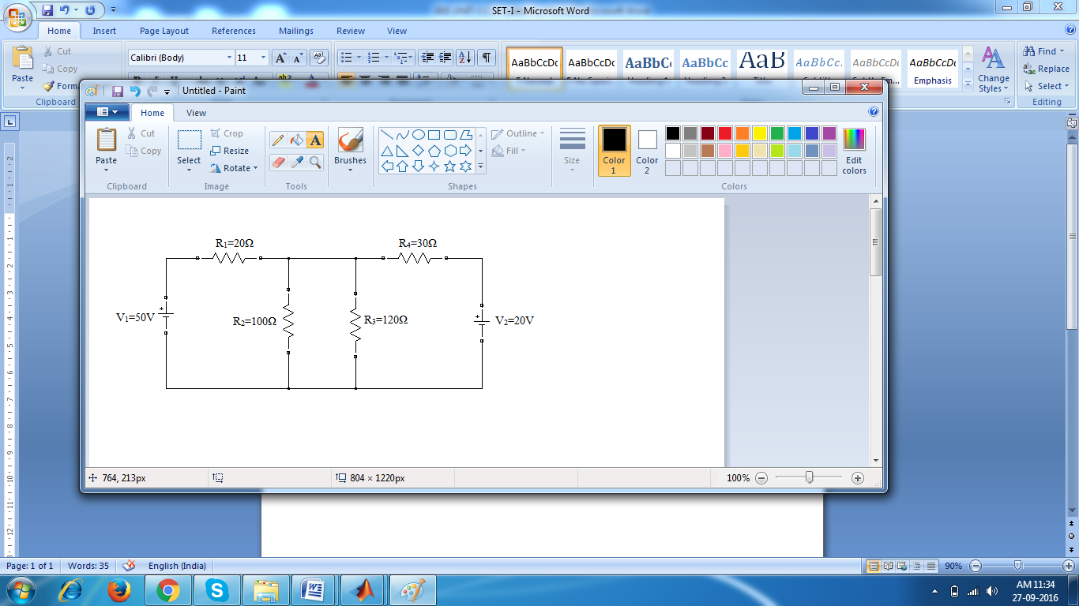  Figure 1 | [5M]
12. |  | Determine the form factor of the waveform shown in figure 2.  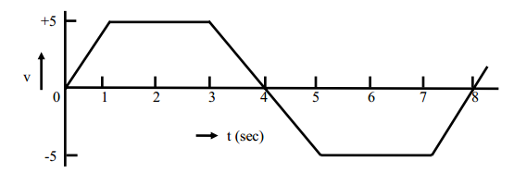  Figure 2 | [10M]
13. | a) | Explain various losses that are occur in a DC machine and also give an expression for efficiency. | [5M]
 | b) | An 8-pole lap-wound Dc generator armature has 960 conductors, a flux per pole of 40mwb and a speed of 400 r.p.m. Calculate the e.m.f generated on open circuit. If the same armature is wave wound, at what speed must it be driven to generate 400V? | [5M]
14. | a) | Derive the EMF equation of a single phase transformer. | [5M]
 | b) | Explain the principle of operation of transformer with neat diagram. | [5M]
15. | a) | Explain the principle of operation of three phase induction motor. | [5M]
 | b) | A Three phase induction motor wound for 4 poles and is supplied from 50Hz system. Calculate i) synchronous speed  ii) the speed of motor when slip is 4%  iii) the rotor current frequency when the motor runs at 600 r.p.m. | [5M]
16. | a) | Explain the operation of Permanent Magnet Moving Coil (PMMC) instruments. | [5M]
 | b) | A moving coil instrument whose resistance is 25Ω gives a full scale deflection with a current of 1mA. This instrument is to be used with a shunt resistance to extent its range to 100mA. Find the value of shunt resistance. | [5M]
17. | a) | Classify types of elements in the electrical circuits and explain them? | [5M]
 | b) | Find current through the element AB for the circuit shown in figure 1 using nodal analysis?  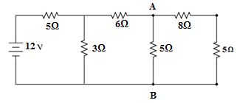 | [5M]
18. | a) | Explain about types of losses that occur in a transformer. | [5M]
 | b) | Obtain the expression for torque of an induction motor. | [5M]

-- 00 -- 00 –

